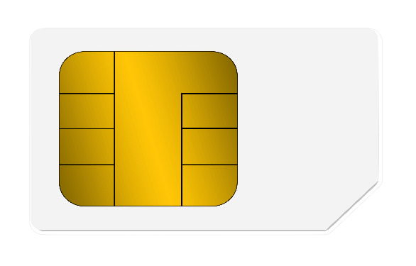

MINTU KUMAR GIRI BANK NAME -SBI

8581 9738 6387

1234 VALID THRU -03/30

MINTU KUMAR GIRI

VALID